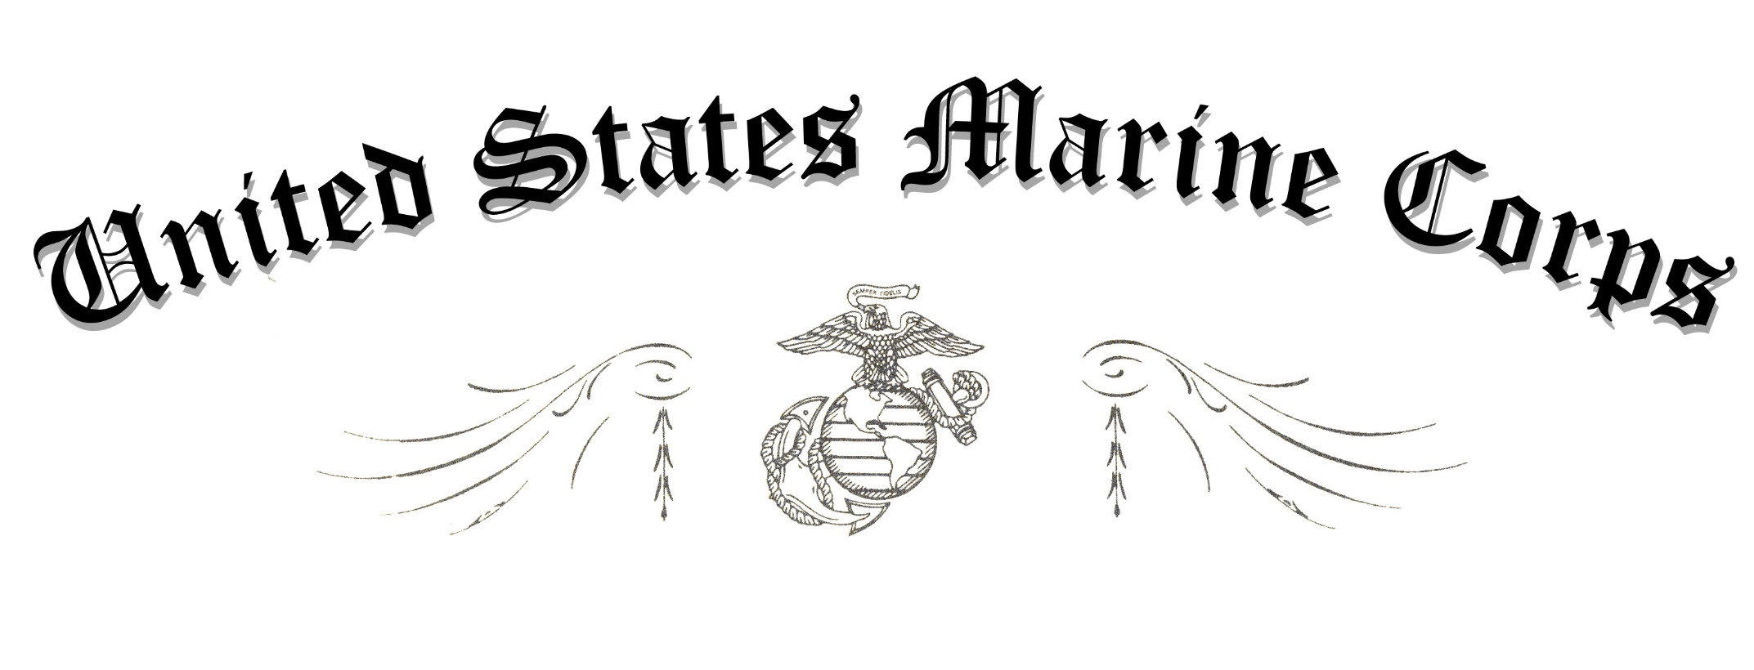
REGINALD J. MCCLAM
COLONEL, U.S. MARINE CORPS
COMMANDING OFFICER
THE BASIC SCHOOL

October 31st, 2023

date

WAS FLOWN OVER THE BASIC SCHOOL,
CAMP BARRETT, STAFFORD, VIRGINIA
ON the 31ST OF OCTOBER 2023 IN HONOR OF
Lieutenant colonel ian j duncan
IN RECOGNITION OF 20 YEARS OF FAITHFUL SERVICE

THE ACCOMPANYING AMERICAN FLAG
This is to certify that

